**Topic 3: Commodities**

Key Concepts in Commodity Market Analysis

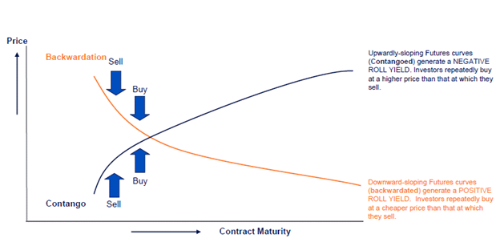

* Backwardation
* Cash-and-carry arbitrage
* Consumer surplus
* Contango
* Convenience yield
* Cost of carry
* Durable assets
* Forward curve
* Liquidity Preference Hypothesis
* Normal backwardation
* Normal contango
* Preferred Habitat Hypothesis
* Rational Expectations Hypothesis
* Real assets
* Segmented market
* Stock-out

**1. Explain the differences between real and financial assets.**

* Real assets are sometimes called economic assets as they can be used or consumed. They are tangible assets with intrinsic value that offer a reasonable expectation of inflation protection.
  + Commodity futures are considered real assets.
  + Real estates, factories, patents, certain types of real options, and human capital are examples of real assets.
  + Durable: assets that are not used up in the wealth production process
  + Non-Durable: assets that are consumed in the wealth production process (e.g. fuel for transport vehicles)
* Financial assets are claims on real assets or cash flows deried from the utilization of real assets.

**2. Explain the role of investors in commodity markets.**

* There are several ways to consider investing in commodities. One is to purchase varying amounts of physical raw commodities, such as precious metal bullion. Investors can also invest through the use of futures contracts or exchange-traded products (ETPs) that directly track a specific commodity index. These are highly volatile and complex investments that are generally recommended for sophisticated investors only.
* Another way to gain exposure to commodities is through mutual funds that invest in commodity-related businesses. For instance, an oil and gas fund would own stocks issued by companies involved in energy exploration, refining, storage, and distribution.

**3. Explain the concept of a convenience yield and how it relates to the cost of carry and a commodity futures price determination.**

* Convenience Yield: this is the non-monetary benefit that comes from physical possession of an asset. It is literally a measure of the convenience of having the asset available to use.
* It is often compared to the dividend stream paid by a stock.
* For example, a manufacturing firm benefits from having a ready supply of copper so that a temporary copper shortage will not disrupt their operations.

**4. Explain the theories of commodity forward curves.**

Pure (Rational) Expectations Hypothesis

Futures prices are an unbiased predictor of the expected future spot price. Buy undervalued securities and sell overvalued ones. This process is known as Relative Value Arbitrage.

Preferred Habitat

Commodity producers who sell contracts to hedge prefer long maturity futures. This leads to NORMAL BACKWARDATION.

Storage Models

Consider the impact of current and expected future storage levels.

Liquidity Preference Hypothesis

Under this model it is assumed that speculators hold all long futures positions, creating a shortage of long futures positions. This shortage causes commodity users to transact primarily in the highly liquid spot market and only rarely to use the forward market for hedging.

Segmented markets

In some cases, geographic separation or market frictions cause markets for the same product to operate independently (i.e., segmented). This causes the forward curve to be useless since spot traders and futures traders act without regard to each other.

Option Based Models

These models rely on real options to describe the forward curve. Extraction option allows the producer to decrease production and the Inventory option relates to the preferred position of holding commodity inventories. Commodities are less volatile when prices are falling since the resulting surpluses are less important than shortages. The asymmetry of the volatility leads to a downward sloping forward curve.

Role of Commodities in Asset Allocation

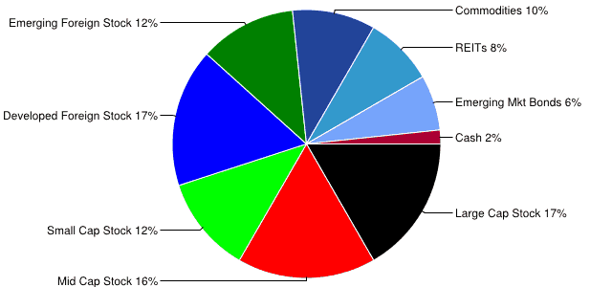

* Diversification return
* Income return
* Roll return
* Scarcity
* Spot return

**1. Discuss the evolution of the role of commodities in asset allocation.**

* GSCI was launched in 1988. It is a production weighted index largely comprised of commodity futures that historically had downward sloping forward curves.
* As the portfolio becomes more diversified, the portfolio geometric return gets closer to the portfolio arithmetic return.
* Risk premiums for commodity futures are largely dependent on STORAGE levels and therefore vary across commodities and across time.

**2. Describe the 3 sources of return to commodity investment and speculation.**

1) Spot return

2) Collateral Return or Income Return – interest earned on risk free assets

3) Roll return

**3. Discuss the concept of SCARCITY in commodities and explain how it impacts investors.**

* Scarcity in commodity markets can provide a source of return to commodity investors, but the difficulty can be in determining when this market pattern is occurring.
* Causes BACKWARDATION

**4. Analyze the statistical properties of commodity prices and discuss the reasons that historical commodity prices may be of little value in predicting future returns.**

* Are returns positive or negative? Inconclusive
* What factors determine commodity performance?

Autocorrelation & Price Spikes are features common to the price series of major commodities and are therefore major determinants of return. Authors point out that commodity STORAGE is the cause of the AUTOCORRELATION.

* Are volatility shocks likely to PERSIST over time? YES
* Are MOMENTUM strategies profitable? YES

Methods of Delivering Long Commodity Exposure

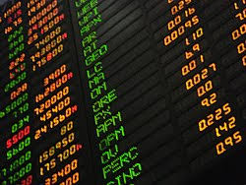

* Indirect commodity investment Private commodity partnership

**1. Explain why indirect ownership of commodities has been mostly preferred over direct physical ownership.**

* Direct: Production, transportation, and marketing of commodities. Some of these investments have returns that are highly correlated with specific commodities, while others do not.
* Indirect: Investing in stocks or bonds issued by commodity products is the most common direct strategy, though there are many others.

**2. Discuss the pros and cons of the following investment vehicles of indirect ownership of commodities: commodity mutual funds and ETFs, long-biased hedge funds, private commodity partnership, commodity trade financing, production financing, public commodity-based equities, bonds issued by commodity firms,**

INDIRECT ownership of commodities

* Mutual Funds
* ETFs
* Long Biased Hedge Funds --
* Private Commodity Partnerships -- (MLPs)
* Trade and Production Financing -- Investment pool lending
* Public Equities of Commodity Firms – Cargill Debt/Equity
* Bonds of Commodity Firms – Cargill Debt/Equity. Bonds that offer the highest exposure to the commodity market in which the companies are involved are Single-C rated bonds.
* If direct commodity trading doesn’t appeal to you, you can choose exchange-traded notes (ETNs) and exchange-traded funds (ETFs). Simply put, you don’t need to invest directly in contracts, but just capitalize on the commodity price fluctuations. This means that commodities trade like stocks, without management and redemption fees attached. However, there could be a discrepancy between the underlying ETNs or ETFs and market transactions.
* Investing via index funds and mutual funds is another type of an indirect approach to commodity trading. They don’t invest in commodities directly, but rather stocks of companies in commodity-related industries (e.g. mining). The downsides are the non-pure play on prices and high management fees.

Methods of Delivering Commodity Alpha

* Bear spread
* Bull spread
* Calendar spread
* Commodity derivatives
* Commodity rights
* Crack spread
* Crush spread
* Enterprise value
* Location spreads
* Processing spreads
* Quality spreads
* Storage strategy
* Substitution spreads

**1. Explain the differences between fundamental and quantitative directional strategies.**

* Fundamental: Use supply and demand analysis as well as an analysis of fundamental economic factors
* Quantitative Directional Strategies: Identify undervalued or overvalued commodities using technical and quantitative indicators (e.g., moving average systems).

**2. Describe relative-value strategies and discuss the three risk dimensions possible in Relative-Value strategies.**

1. Location
2. Correlation
3. Time

**3. Describe the different time spreads possible in commodity investing and fully explain and demonstrate in which cases it might be appropriate to utilize each strategy.**

* Calendar spread: Bull & Bear. Depends on the front month

**4. Describe the correlation spreads possible in commodity investing, and fully explain and demonstrate under what circumstances each would be profitable.**

Correlation spreads are divided into three/four categories:

* Processing Spreads:
  + Crack Spreads: Crude oil, Gasoline, and Heating Oil. Usually represented by X:Y:Z. Long, short, short. Hint: Think ‘cracked’ windshield on car.
  + Crush Spreads: Soybeans, Soybean Meal, Soybean Oil. Long, short, short respectively.
* Substitution Spreads
  + Heating Oil versus jet fuel or gasoline
  + Corn vs. Soybeans
* Quality Spreads
  + Jet Fuel
  + Diesel Fuel
  + Heating Oil
* Location Spreads
  + Long and short positions on the same commodity, but with different delivery locations

**5. Describe Intra-Market Relative-Value strategies and fully explain and demonstrate in which cases it might be appropriate to utilize each strategy.**

* Storage strategies - typically are hedge transactions, involving a simultaneous purchase of the physical asset and sale of the commodity in the futures or OTC forward market.
* Transportation strategies – involves leased transportation service such as tanker, bulk shipping, or pipeline to physically move a commodity from a location where the commodity is in surplus to a LOCATION where it is in shortage.

**6. Explain the difference between equity-based and debt-based commodity strategies and explain under what circumstances each would be implemented.**

Equity based commodity strategies

* COMMODITY RIGHTS
* Enterprise Value (EV)

Debt strategies

* Hedge a commodity firm’s BOND default risk

Commodity Indices



* Commodity beta
* Commodity index
* Commodity weights
* Diversification
* Dynamic asset allocation
* Excess return index
* Maturity

**1. Describe total return and excess return commodity indexes and describe their differences.**

* Total Return Index: Fully collateralized and includes Risk Free Rate.
* Excess Return Index: Tracks return of uncollateralized portfolio

**2. Describe the following possible factors of return to commodity indexes: Beta, roll return, spot return, dynamic asset allocation, diversification, commodity weights, maturity, and T-bill.**

* Commodity Beta:

The return to holding the active futures contact until the contract roll date and then rolling to the next active futures contract.

* Roll Return:

The profits or losses generated from the rolling of futures contracts.

* Spot Return:

The difference between the excess return of an index and the roll return is referred to as the spot return.

* Dynamic asset allocations

Strategies include short term momentum and long term mean reversion can have a significant impact on returns.

* Diversification

Lowers portfolio volatility

* Commodity weights

Index weightings should have a solid economic rationale rather than just allocating to past performers.

* Maturity

Liquidity is less predictable with longer maturities.

* Treasury

Total returns include the risk-free return earned on collateral.

**3. Explain and calculate the following four measures of commodity INDEX returns:**

1. Spot roll = % change in the futures AFTER adjustments for the index
2. Excess return = % change in the futures BEFORE adjustments for index
3. Total return = Risk(free) + Excess Return
4. Roll return = Excess Return – Spot Return

**4. Explain the primary differences among the major commodity indices (candidates should concentrate on describing which type of environment each commodity index would benefit from).**

S&P GSCI (SPGSCI)

 

* Heavily weighted in energy. 6 energy products. Goldman Commodity Index.
* 68% of index is allocated to energy.
* Contract maturities are short. Six Months.

DJAIG Dow Jones AIG Index



* Limits maximum weight of any of the commodities to 15%. Very balanced. ONLY Index in BACKWARDATION where it performs well.
* The Dow Jones Commodity Index (DJCI) is a broad measure of the commodity futures market that emphasizes diversification and liquidity through a simple, straightforward, equal-weighted approach.
* Its weightings are adjusted annually to ensure that no individual commodity or commodity groups hold a disproportionate influence over the index total.
* The index tracks 28 different commodities, from agricultural to precious metals to energy products

BCI Bache Commodity Index



* Contango is good. Has lower Drawdowns. Employs Upper and Lower Limits.
* The development of the BCI represents a significant advancement in commodity indexing methodology. The index was designed using the view that the way commodities are held in a commodity index is as important as the choice of commodities and weights. Actively managed commodity programs do not hold a constant level of exposure either to individual commodities or to the commodity markets as a whole. Rather, an active manager varies exposure to particular commodities and sectors over time.
* The BCI is the first commodity index to incorporate this feature of dynamic asset allocation into an indexing framework. This is achieved while still preserving the essential properties that make commodity investment attractive to many institutional investors.

RICI Rogers International Commodity Index

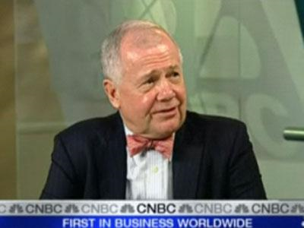

* Designed by investor Jim Rogers. 1998. Quantity based. He loves commodities.
* Performs best when the US dollar depreciates, and agriculture outperforms metals and energy.

MLCX Merrill Lynch Commodity Index



* Has a longer average maturity then SPGSCI and DJAIG

CRB Reuters/Jefferies CRB Index Commodity Research Bureau

* Established in 1957, is a value-based index with the longest history of all the commodity indices. Has the largest allocation to agriculture of any index.

DBLCI Deustch Bank Liquid Commodity Index



* Value based. Highly liquid. Contango is good. Performs best when forward curves are upward sloping and when grains and energy perform well.

DCI Diapason Commodities Index

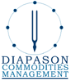

* Broadest available.
* Based in Switzerland and London.
* Performs well when illiquid markets TREND higher

JPMCCI JP Morgan Commodity Curve Index

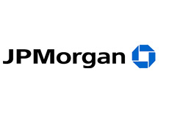

* New concept. Holds the entire commodity curve as opposed to holding only the front contracts.
* Performs well when front contracts underperform deferred contacts and outperforms other indices when roll returns are negative.

CMCI UBS Bloomberg Constant Maturity Commodity Index

UBS AG

* Series of value-based commodities
* Value based.
* Constant maturity of 3 months to 5 years.
* Performs well in Contango.

Investment Vehicles and Asset Allocation

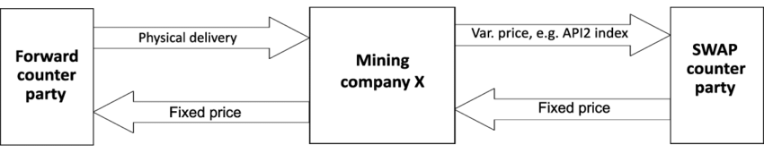

* Commodity index swap
* Commodity index-linked note
* Exchange traded funds (ETF)
* Exchange-traded notes (ETNs)
* Leveraged notes
* Principal-guaranteed notes

**1. Describe and compare the following families of commodity structure products and investment vehicles**

To gain exposure to commodities:

* Delta-one index-linked structures 1:1 with assets

1. Commodity index swaps
2. Commodity index-linked notes
3. ETFs
4. ETNs

* Leveraged and option-based structures

1. Leveraged Notes: offers multiples of exposure to commodities. Contain an embedded (PUT)
2. Principal Guaranteed Notes: Note participates in commodity index increases, but principal is protected form index declines by switching out of commodities and into (BONDS)

* Hedge funds & fund of funds.

**2. Describe the reasons why commodities have been proven to enhance the risk adjusted returns of diversified portfolios. RaR**

* Because they have low correlations with the returns of Stocks and Bonds
* Have low and sometimes negative correlations with the returns of other commodities
* With the S&P and bonds the correlation becomes MORE NEGATIVE as the time horizon increases

3. Describe the evidence on commodities providing hedging against inflation risk.

* Gorton and Rouwenhorst find that commodity futures returns are POSITIVELY correlated with Inflation

Facts and Fantasies about Commodity Futures

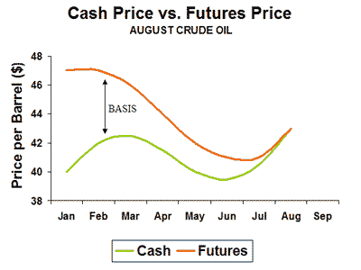

* Backwardation
* Basis
* Risk premium

**1. Illustrate how an investment in commodity futures can earn a positive return when spot commodity prices are falling.**

* This can occur if the market is in normal backwardation. Do the math on it. All about basis. Example in the exam.

**2. Compare commodity spot returns and commodity futures returns.**

FUTURES RETURNS > SPOT RETURNS

**3. Compare commodity futures returns with stock returns and bond returns.**

* Futures Returns = Broad based large capitalization equity index
* Commodity futures > CORPORATE BONDS

**4. Compare commodity futures risk with equity risk.**

* FUTURES RETURNS = LARGE CAP PORTFOLIO

**5. Discuss the use of commodity futures as a hedge against inflation (I).**

* Commodities provide Positive Correlation during times of Inflation

**6. Explain the diversification benefits of commodity futures.**

* Returns between commodities and equities are generally negative. So, they it is good for **diversification.**

**7. Describe the performance of commodity futures from a non-US investor’s perspective.**

* Non-US investor still benefits from commodity performance. Non-US investment returns = US dollar-based investor.

**8. Describe the difference between normal backwardation and a market that is in backwardation.**

* Normal Backwardation is the expected future Spot return

**9. Describe a trading strategy that uses basis in futures markets as an indication of risk premium in futures markets**

* Basis of futures can be defined as the difference between the spot price and the futures price.
* Go Long Low Basis futures
* Go Short High Basis futures

The Strategic and Tactical Value of Commodity Futures



* Arithmetic return
* Contango
* Geometric return
* Normal backwardation
* Roll return

**1. Discuss reasons why the performance of rebalanced Equally Weighted Commodity futures portfolio should not be used to represent the return of commodity futures asset class.**

* EQUALLY WEIGHTED PORTFOLIO NOT A GOOD REPRESENTATION

**2. Explain why the three most commonly used commodity futures indices (GSCI,**

**DJ-AIGCI, CRB) show different levels of return and volatility over a common time period.**

1. GSCI
2. DJ-AIGCI --- Has best return of 7.8%. And highest volatility. SD of 11%.
3. CRB --- Commodities Research Bureau

**3. Explain how the returns of a single cash-collateralized commodity futures and a portfolio of cash-collateralized commodity futures can be decomposed into various sources of return.**

* Single Cash collateralized futures Returns

1. Cash collateral return
2. Excess return earned on the futures contract

* Portfolio of Cash collateralized futures Returns

1. Cash collateral return
2. Excess return earned on the futures contract
3. Portfolio’s excess return

**4. Discuss the four theoretical frameworks (CAPM, the insurance perspective, hedging pressure hypothesis, theory of storage) used to explain the source of commodity futures excess returns.**

Excess returns are caused by:

1. CAPM – Betas should be close to zero, so not very useful. Invalid.
2. Insurance perspective -- normal backwardation
3. Hedging pressure hypothesis – backwardation and contango
4. Theory of storage -- storage, convenience yield, risk free return

**5. Explain the concepts of contango, normal backwardation and market**

**backwardation.**

* Normal Backwardation: the current futures price is less than the expected Futures Spot
* Normal contango: the current futures price is greater than the expected Futures Spot
* Market Backwardation: the current futures price is less than the current spot price
* Market contango: the current futures price is greater then the current future spot price
* NOTE: Normal backwardation and Normal contango market structures can have positive or negative basis

**6. Calculate the roll yield of a commodity futures contract in backwardation or**

**contango.**

* F0 / F1 – 1
* Negative for Contango. Positive for Backwardation.

**7. Discuss the importance of roll returns in explaining the long-run cross-sectional variation of commodity futures returns and the implication for investors.**

* ROLL RETURN EXPLAINS THE MOST

**8. Describe the relative importance of the volatility of spot returns and roll returns in determining the volatility of futures returns.**

* SPOT VOLATILITY > ROLL VOLATILITY

**9. Describe the impact of inflation and unexpected changes in the rate of inflation on individual commodity contracts, sectors, and diversified commodity portfolios and indices.**

* Inflation sensitivities vary across individual commodity futures
* Inflation sensitivity increases with roll returns
* Inflation depends on the portfolio composition
* Inflation sensitivity is highest for portfolio that heavily weight difficult to store commodities

**10. Explain how rebalancing and diversification can impact the geometric rate of return of a portfolio in comparison to its arithmetic rate of return.**

* With Diversification: Geometric 🡪 becomes Weighted Arithmetic Geometric Mean
* If not rebalanced, diversification return is decomposed into two parts 1) effect of variance reduction and 2) effect of not rebalancing
* Not rebalancing reduces the diversification return

**11. Discuss the effectiveness of tactical asset allocation (TAA) in commodity portfolios using strategies based on momentum and the term structure of futures prices.**

* Momentum strategies:
  + Long GSCI
  + Long positions in previously best performing
  + Long positions in previously positive performing commodity futus
* Term Structure strategies:
* Short contracts in Contango
* Long contracts in Backwardation

**12. Argue Against the use of naïve extrapolation of past commodity returns to forecast future performance and discuss the importance of formulating forward-looking expectations.**

* Investors are cautioned NOT to use naïve extrapolation
* Individual excess returns of individual commodities are close to zero
* Portfolios of commodity futures have performed better and may exhibit equity-like returns

The Oil-Price Spike of 2008: Inferences from Price Relationships and Other Publicly Available Data

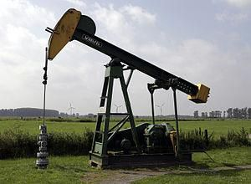

* Baltic Dry Index Crack spread

The index tracks worldwide international shipping prices of various dry bulk cargoes.

* Negative gamma

**1. Explain the role of price from a futures trader’s perspective.**

* A future’s trader interprets a commodity’s price as part of a dynamic process.

**2. Identify and explain the fundamental factors that have caused the oil prices to increase since 2000.**

* Demand: global demand for crude oil increased by 9 million barrels per day. Shifting to countries like India, China, and the Middle East.
* Supply: only increased by 4 million barrels a day. OPEC has shown some resistance in increasing production.
* Supply/Demand relationship: International Energy Agency estimates that the difference between daily supply and demand is less than 1 million barrels or approximately 1%. The EU and the United States have required lower sulfur content in diesel fuel sold in these countries to improve the fuel.

**3. Identify the possible obstacles to predicting the Supply and Demand for oil products.**

1. Shifting Demand Growth (demand is shifting to India and China)
2. Lack of transparency regarding Chinese oil usage and stockpiles (Olympic inventory)
3. Lack of transparency in the energy TRADING markets (OTC trading is obscure)
4. Market disruptions (Hurricanes)

**4. Explain the impact of the rising Chinese demand for oil products on the world prices of oil products.**

1. 2008 Sichuan earthquake



1. 2008 Beijing Olympics



1. Imports and shipping costs

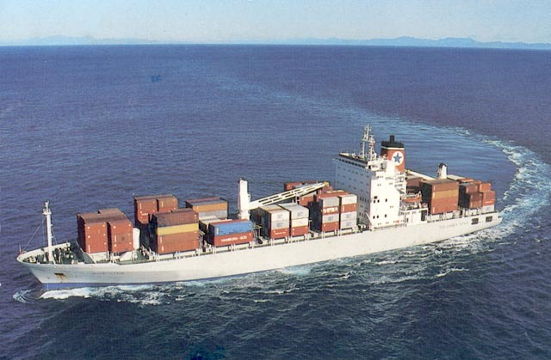

**5. Illustrate how STURCTURAL BREAKS could lead to misinterpretation of fundamental information from price-relationship data, using crude oil market data from 1986-**

**2007.**

1. 2005 Heating Oil Premium
2. 2008 Gasoline and Heating Oil Crack Spreads
3. Chinese Holidays

**6. Discuss the role of transparency in futures trading in price discovery (given the inadequate fundamental data).**

1. Stockpiling by Chinese
2. Global oil supply and demand are extremely tight
3. Oil futures markets can provide price signals
4. Current price relationships are dependent on current, not historical, market factors

After the 2008 Olympics the supply of oil increase, resulting in a decrease in oil prices.

**7. Explain how various activities of market participants impact the price of oil products.**

1. Short term inelastic supply and demand: oil is very inelastic. Short term inelastic nature of oil causes increased price volatility.
2. Hedging impacts: oil hedges may exacerbate market movements
3. Large scale liquidations: collapse of Amarath a good example
4. Credit Risk: price of oil is affected by any flight to quality – going to bonds

**8. Explain how currency prices impact oil prices.**

* Priced in terms of the dollar. So, weak dollar means higher price of oil.

**9. Present the arguments for oil as a store-of-value.**

* CFTC has researched this issue and found that the increased investor demand is not the cause of the spike in OIL prices.
* Oil can currently be classified as a good store of value.

Commodities and Equities: Ever a “Market of One?”

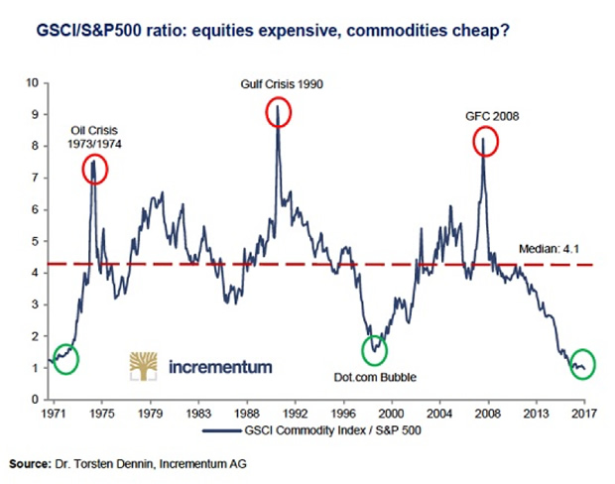

* Co-integration
* Cress market linkage’s
* Extreme Markets
  1. **Describe the two major changes that have taken in commodity markets since 2005 and understand their implications for the relationship between equity and commodity returns.**

1. Fund Increase Holdings
2. Oil Prices Increase big time.
   1. **Argue whether there has been a secular rise in short-term correlations between commodities and equities using simple correlation (SC) and dynamic conditional correlation.**

* NO CORRELATION. Simple correlation analysis does not indicate a secular rise in correlations between commodities and equities.
* NO CORRELATION. Dynamic conditional correlation (DCC) analysis yielded no indication of a secular rise in commodity and equity correlations over the last few years.
  1. **Explain why co-integration may be used to examine the relationship between commodity returns and equity returns.**
* Co-integration techniques assess the LONG TERM relationship between two asset classes to determine whether a common risk factor drives the returns of both
* NO CO-INTEGRATION found between stocks and commodities DURING EXTREME EVENTS
  1. **Describe the statistical evidence on the relationship between commodity returns and equity returns during EXTREME positive and negative market events.**
* Almost no linkage exists between extreme equity and commodity returns.
* Questionable Negative Correlation during extreme events.
  1. **Discuss the implications of this study’s empirical findings for passive equity and commodity investors.**
* Commodity/equity return correlations HAVE NOT persistently increased over the last 17 years. So, investors can still achieve diversification benefits.